Regular Shapes
# Source: AI Source: Provided by: [Data Path: Persons Table -> ID Column: 1, Name_En Column: Motasem Essam] -> From: [ChatGPT] on [7/25/2026]
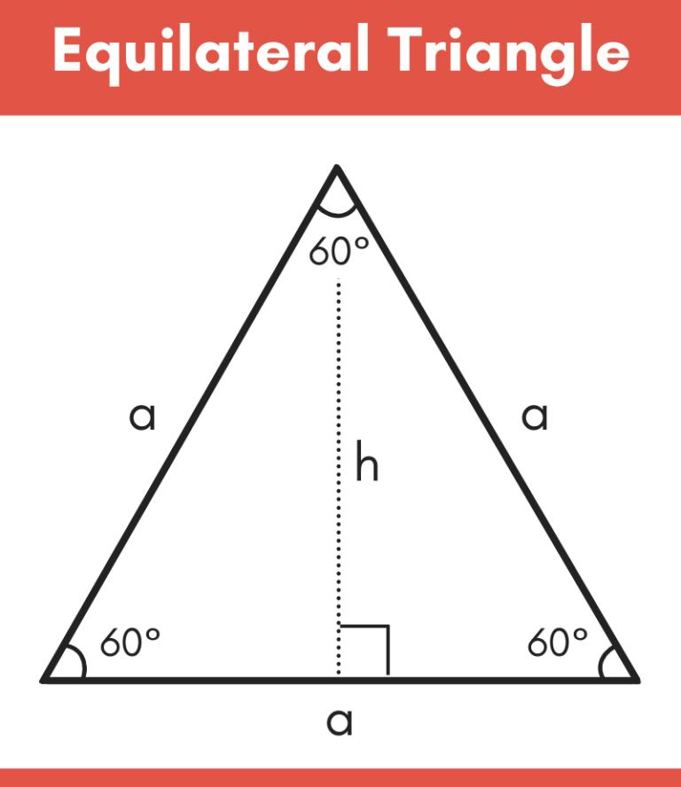
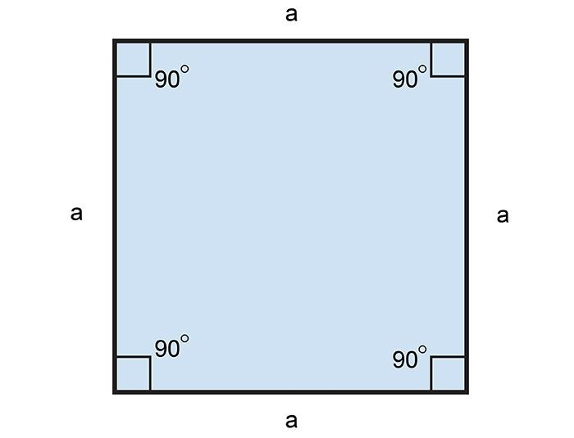
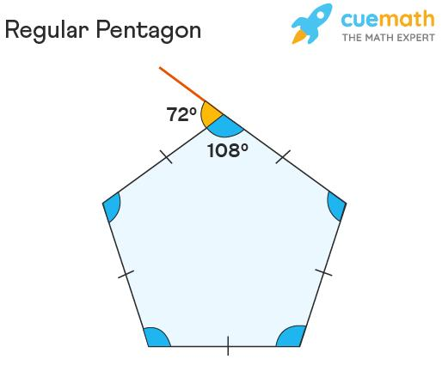
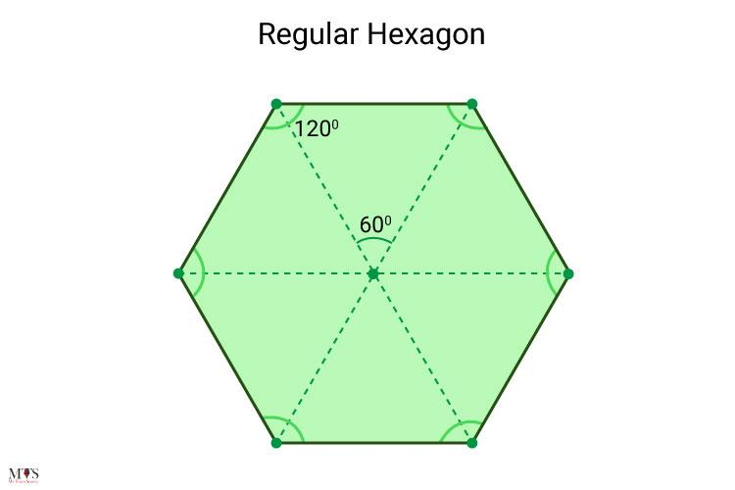
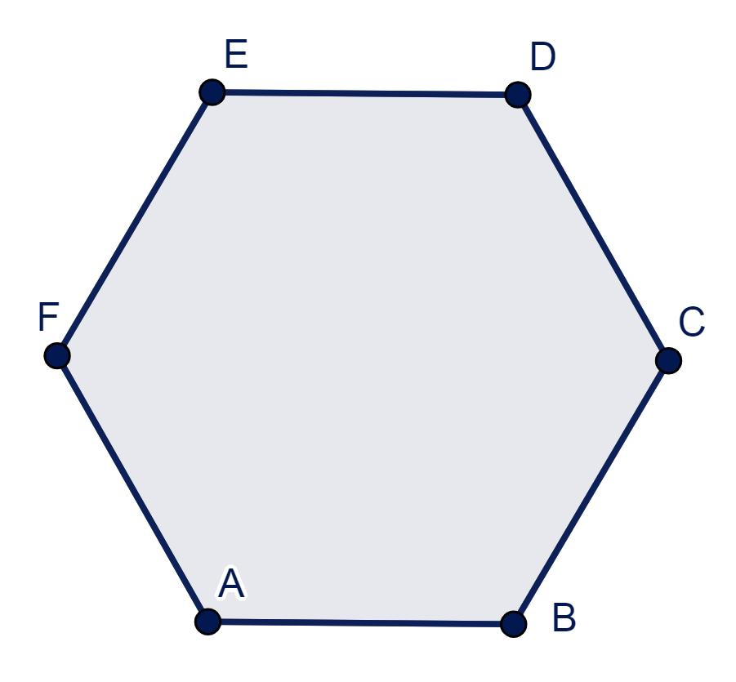

Definition
# Source: AI Source: Provided by: [Data Path: Persons Table -> ID Column: 1, Name_En Column: Motasem Essam] -> From: [ChatGPT] on [7/25/2026]
A Regular Shape is a two-dimensional geometric figure in which all corresponding sides are equal in length and all interior angles are equal in measure.
In elementary geometry, the term regular shape most commonly refers to a regular polygon, although the circle is also often considered a perfectly regular figure because every point on its boundary is equally distant from its center.

Characteristics
# Source: AI Source: Provided by: [Data Path: Persons Table -> ID Column: 1, Name_En Column: Motasem Essam] -> From: [ChatGPT] on [7/25/2026]
A regular shape:
- Has equal side lengths (for polygons).
- Has equal interior angles (for polygons).
- Is highly symmetrical.
- Is always a closed figure.
- Encloses a bounded region.
- Has a well-defined center.
- Can often be inscribed in or circumscribed about a circle.

Illustration

Regular Triangle (Equilateral Triangle)
# Source: AI Source: Provided by: [Data Path: Persons Table -> ID Column: 1, Name_En Column: Motasem Essam] -> From: [ChatGPT] on [7/25/2026]
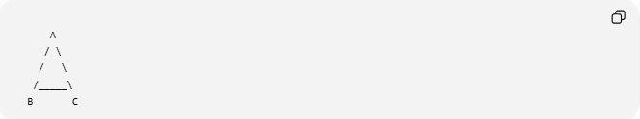
A
/ \
/ \
/_____\
B C
- 3 equal sides
- 3 equal angles (60°)

Square
# Source: AI Source: Provided by: [Data Path: Persons Table -> ID Column: 1, Name_En Column: Motasem Essam] -> From: [ChatGPT] on [7/25/2026]
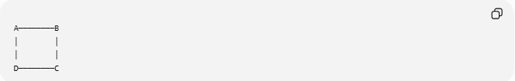
A────────B
│ │
│ │
D────────C
- 4 equal sides
- 4 equal angles (90°)

Regular Pentagon
# Source: AI Source: Provided by: [Data Path: Persons Table -> ID Column: 1, Name_En Column: Motasem Essam] -> From: [ChatGPT] on [7/25/2026]
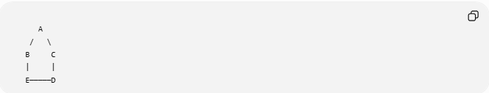
A
/ \
B C
| |
E─────D
- 5 equal sides
- 5 equal angles

Mathematical Representation
# Source: AI Source: Provided by: [Data Path: Persons Table -> ID Column: 1, Name_En Column: Motasem Essam] -> From: [ChatGPT] on [7/25/2026]
For a regular polygon with:
- (n) sides
- Side length (s)
Perimeter:
$$P=ns$$
Interior angle:
$$\boxed{\frac{\left(n-2\right)×{180}^{∘}}{n}}$$
Exterior angle:
$$\boxed{\frac{{360}^{∘}}{n}}$$

Common Regular Shapes
# Source: AI Source: Provided by: [Data Path: Persons Table -> ID Column: 1, Name_En Column: Motasem Essam] -> From: [ChatGPT] on [7/25/2026]
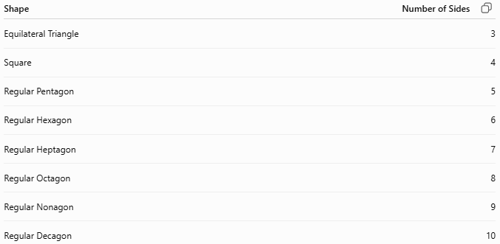
Shape | Number of Sides
Equilateral Triangle | 3
Square | 4
Regular Pentagon | 5
Regular Hexagon | 6
Regular Heptagon | 7
Regular Octagon | 8
Regular Nonagon | 9
Regular Decagon | 10

Circle as a Regular Shape
# Source: AI Source: Provided by: [Data Path: Persons Table -> ID Column: 1, Name_En Column: Motasem Essam] -> From: [ChatGPT] on [7/25/2026]
A circle is often regarded as the most regular plane figure because:
- Every point on its boundary is the same distance from the center.
- It has infinite lines of symmetry.
- It has rotational symmetry through every angle.
Unlike polygons, a circle has:
- No sides.
- No vertices.
- A continuous curved boundary.

Properties
# Source: AI Source: Provided by: [Data Path: Persons Table -> ID Column: 1, Name_En Column: Motasem Essam] -> From: [ChatGPT] on [7/25/2026]
1. Equal Sides
Every side has identical length.

2. Equal Angles
Every interior angle is equal.

3. Symmetry
Regular polygons possess:
- Reflectional symmetry.
- Rotational symmetry.
Examples:
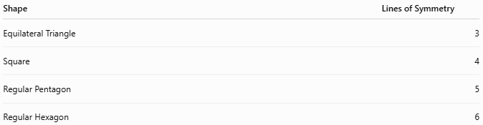
Shape | Lines of Symmetry
Equilateral Triangle | 3
Square | 4
Regular Pentagon | 5
Regular Hexagon | 6

4. Circumscribed Circle
Every regular polygon can have a circle passing through all its vertices.

5. Inscribed Circle
Every regular polygon can contain a circle tangent to every side.

Real-World Examples
# Source: AI Source: Provided by: [Data Path: Persons Table -> ID Column: 1, Name_En Column: Motasem Essam] -> From: [ChatGPT] on [7/25/2026]
Regular shapes appear in:
- Floor tiles.
- Stop signs (regular octagon).
- Honeycomb cells (regular hexagon).
- Coins.
- Decorative patterns.
- Company logos.
- Clocks.
- Snowflakes (approximately hexagonal symmetry).

Applications
# Source: AI Source: Provided by: [Data Path: Persons Table -> ID Column: 1, Name_En Column: Motasem Essam] -> From: [ChatGPT] on [7/25/2026]
Regular shapes are used in:
- Plane Geometry
- Coordinate Geometry
- Engineering
- Architecture
- Tessellation
- Industrial Design
- CAD (Computer-Aided Design)
- Computer Graphics
- Robotics
- Mathematics Education

Advantages
# Source: AI Source: Provided by: [Data Path: Persons Table -> ID Column: 1, Name_En Column: Motasem Essam] -> From: [ChatGPT] on [7/25/2026]
Studying regular shapes helps to:
- Simplify geometric calculations.
- Understand symmetry.
- Compute perimeter and area efficiently.
- Design repeating patterns.
- Model highly symmetric structures.

Limitations
# Source: AI Source: Provided by: [Data Path: Persons Table -> ID Column: 1, Name_En Column: Motasem Essam] -> From: [ChatGPT] on [7/25/2026]
Regular shapes:
- Represent only a small subset of all geometric figures.
- Are less common in naturally occurring irregular objects.
- Cannot model many real-world shapes without approximation.

Comparison with Other Shape Types
# Source: AI Source: Provided by: [Data Path: Persons Table -> ID Column: 1, Name_En Column: Motasem Essam] -> From: [ChatGPT] on [7/25/2026]
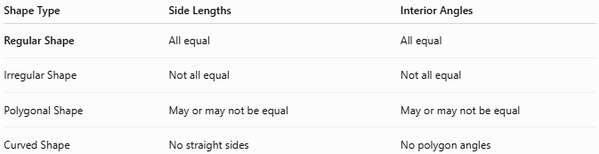
Shape Type | Side Lengths | Interior Angles
Regular Shape | All equal | All equal
Irregular Shape | Not all equal | Not all equal
Polygonal Shape | May or may not be equal | May or may not be equal
Curved Shape | No straight sides | No polygon angles

Key Points
# Source: AI Source: Provided by: [Data Path: Persons Table -> ID Column: 1, Name_En Column: Motasem Essam] -> From: [ChatGPT] on [7/25/2026]
- A Regular Shape has equal sides and equal angles (for polygons).
- It is highly symmetrical.
- Common examples include:
  - Equilateral triangle
  - Square
  - Regular pentagon
  - Regular hexagon
  - Regular octagon
- Regular polygons have simple formulas for perimeter and angles.

Conclusion
# Source: AI Source: Provided by: [Data Path: Persons Table -> ID Column: 1, Name_En Column: Motasem Essam] -> From: [ChatGPT] on [7/25/2026]
A Regular Shape is a two-dimensional figure with equal corresponding sides and equal interior angles, giving it a high degree of symmetry and uniformity. Regular shapes, particularly regular polygons, are fundamental in plane geometry, coordinate geometry, engineering, architecture, tessellation, CAD, computer graphics, robotics, and mathematics, where their predictable properties simplify analysis, measurement, design, and construction.

